Lab Exercise 3- Working with Docker Networking
Name:Prince Singhalia
Sap id: 500120403
Roll no.: R2142231125
Step 1: Understanding Docker Default Networks
Docker provides three default networks:
- bridge: The default network when a container starts.
- host: Bypasses Docker’s network isolation and attaches the container directly to the host network.
- none: No networking is available for the container.
1.1. Inspect Default Networks
Check Docker's default networks using:
docker network ls
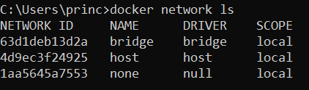
1.2. Inspect the Bridge Network
docker network inspect bridge
This command will show detailed information about the bridge network, including the connected containers and IP address ranges. 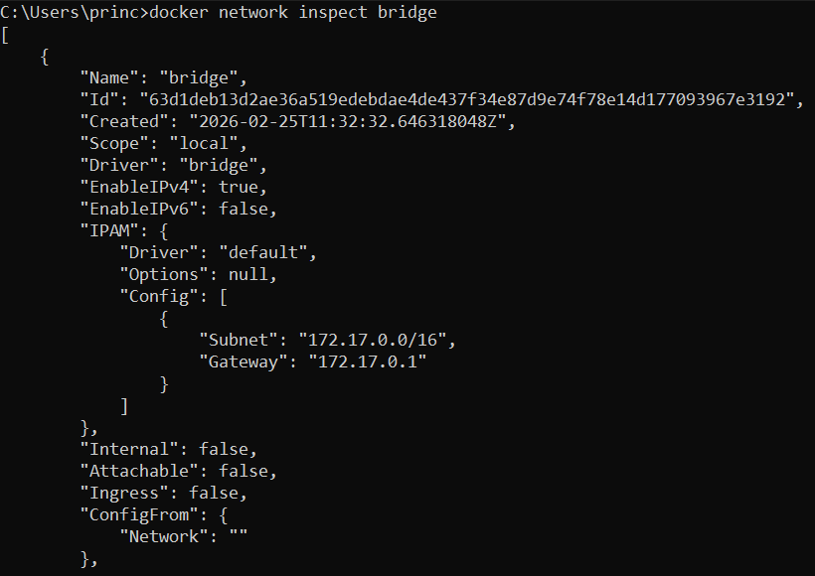
Step 2: Create and Use a Bridge Network
2.1. Create a User-Defined Bridge Network
A user-defined bridge network allows containers to communicate by name instead of IP.
docker network create my_bridge
2.2. Run Containers on the User-Defined Network
Start two containers on the newly created my_bridge network:
docker run -dit --name container1 --network my_bridge busybox
docker run -dit --name container2 --network my_bridge busybox 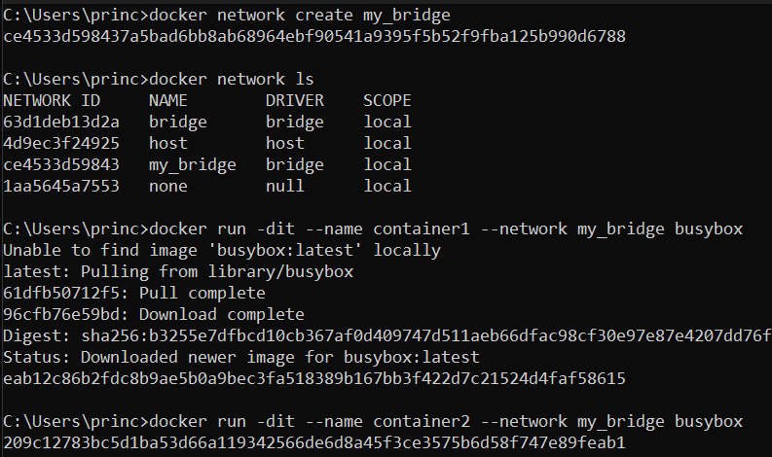
2.3. Test Container Communication
Execute a ping command from container1 to container2 using container names:
docker exec -it container1 ping container2
The containers should be able to communicate since they are on the same network. 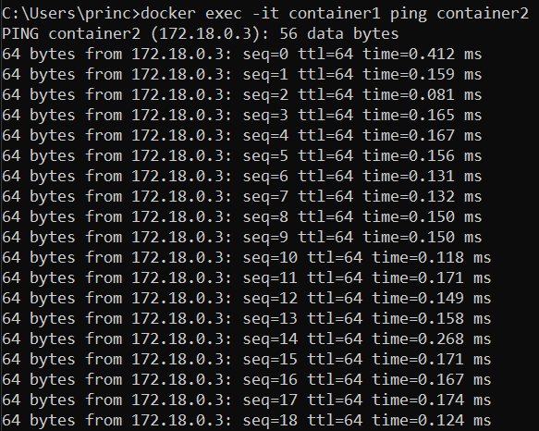
Step 3: Disconnect and Remove Networks
3.1. Disconnect Containers from Networks
To disconnect container1 from my_bridge:
docker network disconnect my_bridge container1
4.2. Remove Networks
To remove the user-defined network:
docker network rm my_bridge
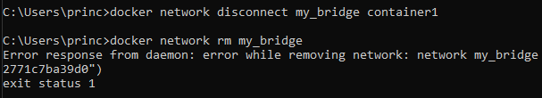
Step 4: Clean Up
Stop and remove all containers created during this exercise:
docker rm -f container1 container2 